Home learning suggestions + tick sheet.
Please complete one activity a day for ‘home learning’. You get to make a choice about what you’d like to do each day. You might like to choose the same, or a similar activity as your siblings from other grades, it’s up to you!
Do not worry if you cannot complete everything during the term, you may not have what is required for it and that’s okay. I may add more as the term goes on so keep a look out!
Please take photos if you can, I’d love to see you all, and we would love to build a community of fun with other students and families.

Home learning activities | Tick it off once completed.
Play any board game with your family.

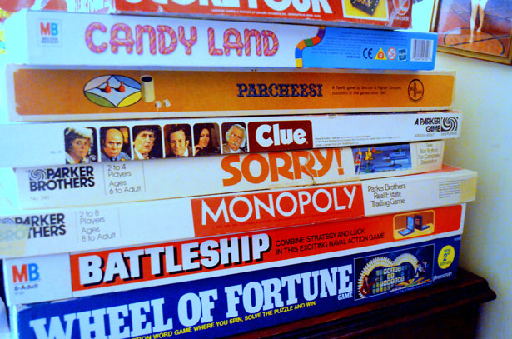

Play a card game by yourself or with a family member.

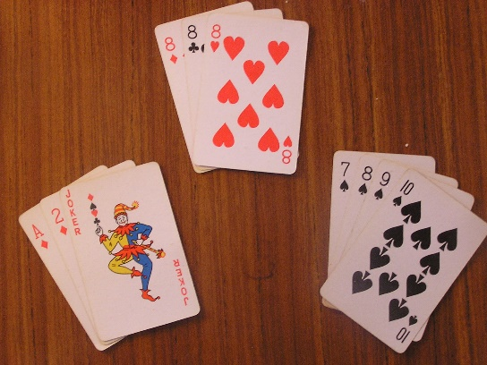
If you have pavement or a timber fence, using tape, mark out a geometric pattern and colour in the shapes with different coloured chalk.
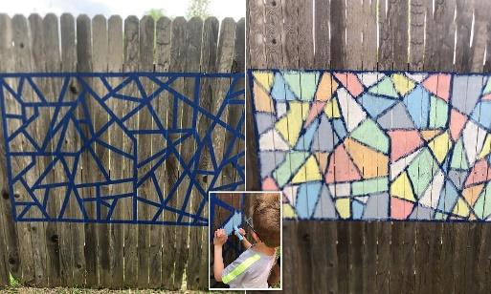
Do you have any favourite-famous-family recipes? Bake with a grown up. Have a go with measuring and combining different ingredients.

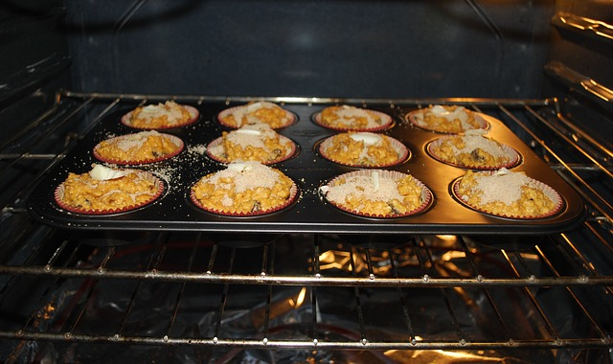

Help prepare dinner

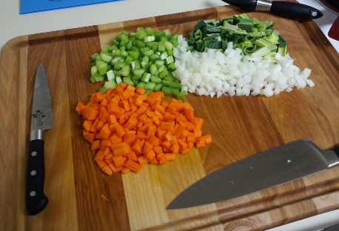

Play a strategy game with a sibling or family member (could be ‘paddocks’ below, or something like connect four).

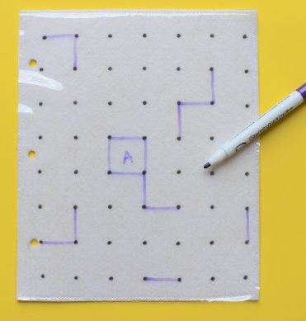

Hang the washing out/fold the washing.

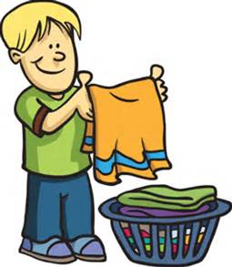

If you have pavement or a timber fence, using tape, mark out a geometric pattern and colour in the shapes with different coloured chalk.
Help with the dishes tonight.
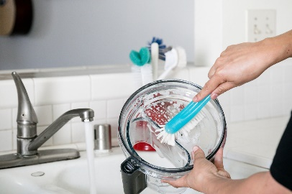

Help a grown up clean out a cupboard, wardrobe, car or room.
Maybe you can try your hand at re-decorating.
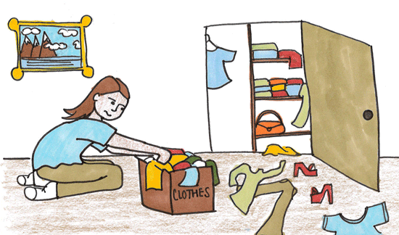
Listen to some music and paint (or draw with pencils, pastels or crayons) to what you hear. It doesn’t have to be a ‘picture’ but rather an artwork that represents what you hear

Star gaze. See if you can identify the following: The Southern Cross, the Milky Way, the Big Dipper.
So, what exactly is a constellation? Do you think if every other child in the world was star gazing right now, would they see the same constellations as you?
Sculpture- Make some salt dough:
https://www.allrecipes.com/recipe/240641/salt-dough/
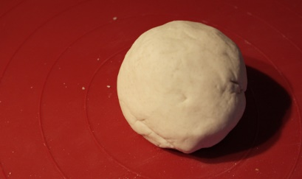
Ideas: A small bowl to hold small items, pencil holder, (you could press leaves onto your creation to create a pattern).
5 senses ‘grounding’ activity.
Find a spot outside and sit comfortably. List 5 things you can see, *now close your eyes for the rest and list: 4 things you can hear, 3 things you can touch, two things you can smell and one things you can taste. Finish off by laying on the ground and finding animals in the clouds!
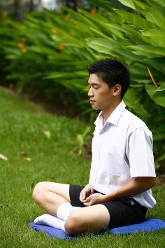
Make an artwork on the ground outside using only items from nature (sticks, leaves, flowers etc.)
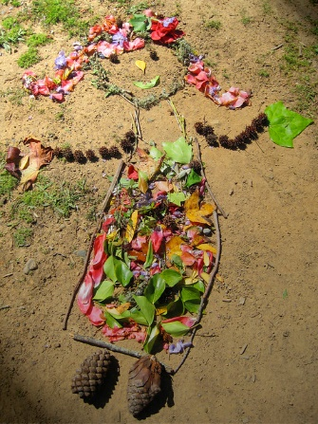

Draw a quick collection of squiggles and shapes, then give it to a partner. They have to try and make a picture out of it.
They then do the same for you!
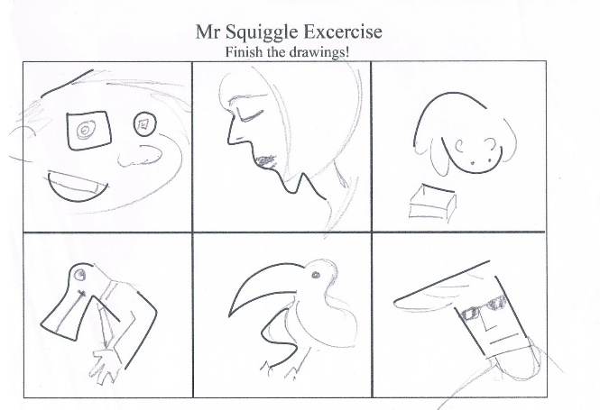
Create your own treasure hunt.
Create a treasure hunt for members of your family using objects around the house and/or . You could create a list for them to find or draw a pirate map with directions.

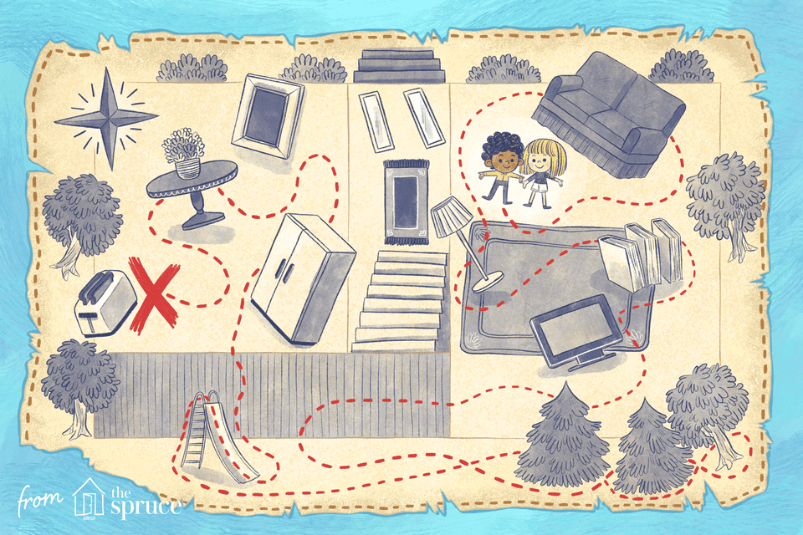

You can create a trophy for the winner!

Make coloured playdough
The link has a recipe for playdough that does not require any cooking. You can use food colouring to make the playdough any colour you like.
https://www.bestrecipes.com.au/recipes/no-cook-playdough-recipe/v7a0hvfx

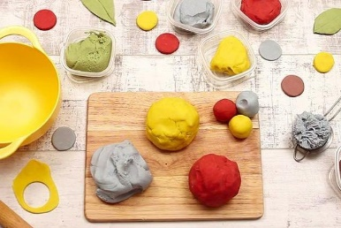
Make your paper fidget spinner
You will need an adults help for this activity.
https://www.youtube.com/watch?time_continue=243&v=CPV_5IjFu5o&feature=emb_title

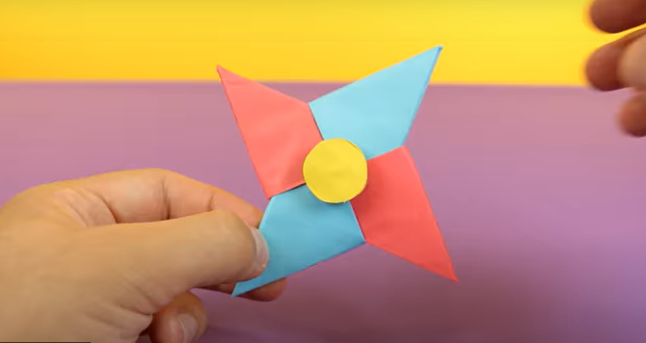

Teach yourself to juggle
Start with 2 balls and then increase. You can watch tutorials online for help.
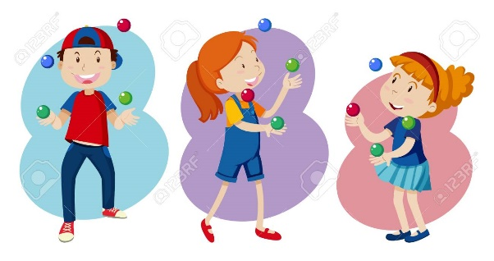

Wash the family car
On a nice afternoon help an adult wash their car.
