Is TV Good or Bad?

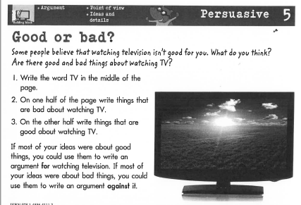

Bad things about watching TV Good things about watching TV

TV

