Write the probabilty of the following events happening. You can use the following probility vocabulary:
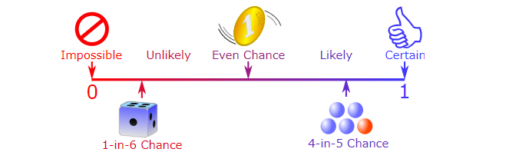
IMPOSSIBLE- the event will definitely not happen.
UNLIKELY- Most likely will not happen.
EVEN CHANCE- It could happen but it also might not happen. 50/50 chance.
LIKELY- There is a good chance this event will happen.
CERTAIN- This event will definitely happen.
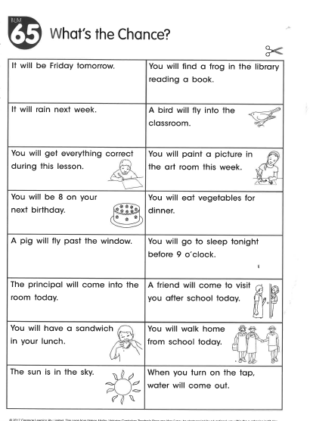
Come up with 5 of your own events and the probability of it happening.

